Edward Schmalz and Andrew Phillips

Historical Battle Simulator (HBS)

Preface
The historical battle simulator(HBS) is designed to be used by instructors, students and war game fans. This is the first version of this product, and it draws a bit of inspiration from existing wargame systems, such as Warhammer, Total War and Risk.

Introduction
This over all system is designed based on the need for a more effective and interactive way to teach history, specially in describing military engagements. This software will be distributed as freeware and will be funded by donations and advertising if it is successfully created and used by instructors.

Glossary
- Combat System Terms
  - Damage Dice– The set of random numbers that a unit does in damage Described as D(for dice). Ex: d10
  - Damage Modifier – The bonus given to the damage a unit does.
  - Charging – Charging refers to a unit attacking after running directly into another unit.
  - Friendly Fire – Refers to when a unit attacks a friendly unit accidentally.
  - Morale – Determines whether or not a unit stands and fights, gets bonuses or negatives, or if they cower and run away.
  - Flanking – Occurs when a unit is directly behind or to the back left or right of a unit.
- Movement System Terms
  - Stamina – Describes how often a unit can trigger the ‘run’ mode, which allows them to travel double. Stamina regenerates at a rate of 1 point when a unit stays still and 1/3 a point when a unit is moving but not running or fighting.
  - Running – When a unit toggles ‘running’ they expend one stamina point in order to travel double the distance that they would initially due to their speed.
- Unit System Terms
  - Unit Attributes – The different elements of a unit.
  - Unit – A collection of the same type of soldier. [this may be potentially modified in future updates
  - Soldier – The representation of a single person in a military unit.

System Requirements Definition
Functional
- Combat System – The program must include a system which uses random numbers in conjunction with precalculated and stored stats for units, modified based on the location and status of the units in order to resolve combat in a turn based fashion.
- Unit System - Each unit must have a set amount of stats, including attack, dmg, armor class, speed, defense, morale, and more. The majority of these will be visible to the user and be constant, whereas some shall be hidden from both the user in control of them and the opponent. Some of these stats will be modified as a result of combat and movement, but not all. Each unit shall consist of a group of soldiers.
- Movement System – A system must exist to allow for units to traverse the map. This system must allow for the units to travel up to twice their speed, if they are using 'run'.
- User Interface [GUI] – There must be a functional, accessible graphical user interface[GUI] that will allow the player to navigate battles with little to no technical understanding of the program. The purpose of this program is to teach them about the battles, not about the complicated programming behind it.
- Map System – A map system must include different elements for each of the square tiles. Each tile should allow only one soldier at a time to occupy it. Each tile may or may not grant additional modifiers for cover or vulnerability.
- Tool Kit – A tool kit must be accessible which shall allow instructors to modify and upload their own maps, units, and place them in such a way to recreate any battle of their choosing.
Non Functional
- Fluidity – The combat system and movement system should operate in a smooth and non-obtrusive way. The program should never be to complex for the user to engage in.
- Interactivity – Combat should remain interactive for the players, throughout the entire duration, and the appeal of combat should not end upon first contact between units.
- Educational – The program should be able to host and allow for any historical scenario to be played out, prior to the invention of automatic weapons and airplanes.

User Requirements
Professor Commands
- Create Unit
  - Actors: Prof
  - Description: Prof will enter in the all information required to create the unit she desires. This information includes all of the following, the name of the unit, the damage of the unit, the attack of the unit, any damage bonuses the unit has, the hp of the unit, the class of armor the unit is wearing, how much defense the unit can put up, the speed of the unit, how far away the unit can fight, how much extra damage the unit gets from charge, and how much morale the unit has ,
  - Data: The information described above, used to create a unit
  - Stimulus: Prof pushes a button
  - Response: A prompt asks him to enter info either manually or word doc
  - Comments: Prof should have an idea on the relative stats for his unit
- Create Map
  - Actors: Prof
  - Description: Professor will (pick a pre-designed map? Add specs for his own map)
  - Data: Information relevant to creating a map
  - Stimulus: Prof pushes a button
  - Response: A prompt asking him to enter informatoin
  - Comments:
All User Commands
- Play Game
  - Actors: Any user
  - Description: User will select a new game and any units created will be shown on board where they were placed. If no customization occurred, a default game will load
  - Data: none?
  - Stimulus: User presses button
  - Response: Game loads and can be seen on screen
  - Comments:

- Select Unit
  - Actors: Any user
  - Description: A user selects a unit, allowing for access to a variety of other options.
  - Data: The unit which has been selected.
  - Stimulus: User clicks on a unit.
  - Response: Change bottom half of the screen to reveal the options:
    - Attack
    - Defend
    - Check Stats
    - Move
    - Special Ability
    - Cancel Selection
- Attack
  - Actors: Any User
  - Description: A user will select a unit to attack another unit
  - Data: Unit stats and opposing unit stats
  - Stimulus: After selecting a unit, the user clicks the attack button[Attack] and than the target of the attack.
  - Response: Prompt asking if you are sure and a play by play of the attack with options to decide
  - Comments:
- Check Current Stats
  - Actors: Any User
  - Description: Clicking on a unit will bring up all of the unit’s stats previously described of the unit class
  - Data: The unit’s stats.
  - Stimulus: Clicking “View Stats” buttons[?]
  - Response: The GUI shows the unit’s stats
  - Comments
- Defend
  - Actors: Any user
  - Description: A user enables the unit to go into defense mode, giving it a defense bonus against attacks.
  - Data: The units defense bonus
  - Stimulus: Clicking Defend button[Shield]
  - Response: “UNITNAME is now defending”
  - Comments:
- Move
  - Actors: Any user
  - Description: A user enables the unit to move from one tile to another. Gives them the option to select either sprint, or move regularly
  - Data: The tile that the user is on, the amount of spaces they can move, whether or not they are sprinting.
  - Stimulus: Clicking Move
  - Response: none
  - Comments:
- Sprint
  - Actors: Any user
  - Description: After selecting move, the user is queued to either select sprint, or not.
  - Data: How many stamina points the unit has.
  - Stimulus: After the user selects move, they are given a prompt.
  - Response: none
  - Comments:
- Special Ability
  - Actors: Any user
  - Description: A unit may possess a special ability[ie: phalanax mode, berserk mode, rally, etc] and this allows them to activate it.
  - Data: What a units special ability is, and whether or not it is active.
  - Stimulus: A user clicks this option.
  - Response: text box confirms that special ability has been activated
  - Comments
- Cancel
  - Actors: Any user
  - Description: This allows a user to cancel selecting a unit and select another one.
  - Data: UnitSelected
  - Stimulus: A user clicks this option
  - Response: A target is no longer selected
  - Comments: This allows a user to switch to make another move before using this unit.
- End Turn
  - Actors: Any user
  - Description: Allows a user to end there turn.
  - Data: Turn active
  - Stimulus: A user clicks this option, which will be in the bottom right hand of the screen.
  - Response: Prompt returns with a statement that the user’s turn has ended
  - Comments
- Save
  - Actors: Any User
  - Description: Allows user to save and come back to the simulation later
  - Data: All data
  - Stimulus: A user clicks this option
  - Response: None
  - Comments

Create Unit

Create Map

Creator

Save

Cancel
Selection

Attack

Select Unit

Play Game

Move

Defend

Special Ability

Sprint

Check Current Stats

Player

Save

End Turn

GameBoard with no Unit Clicked
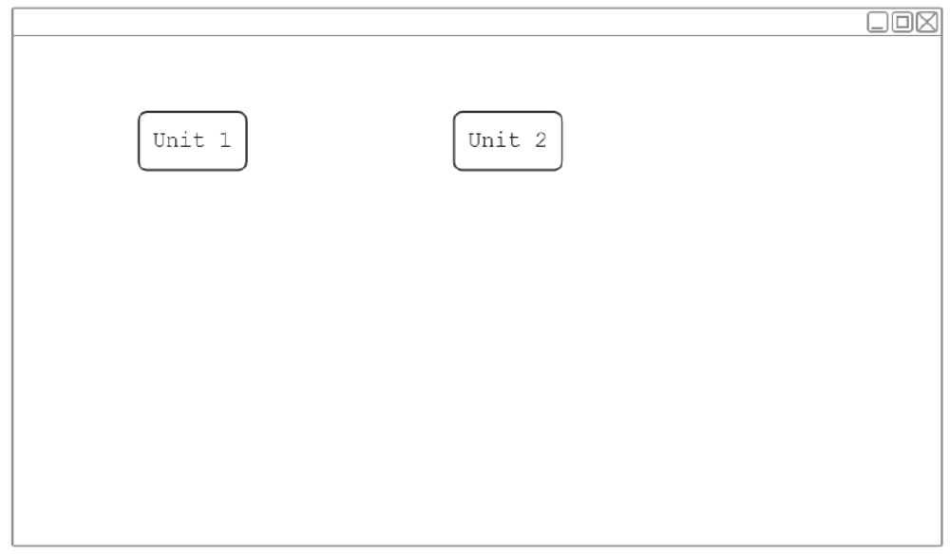
MenuScreen
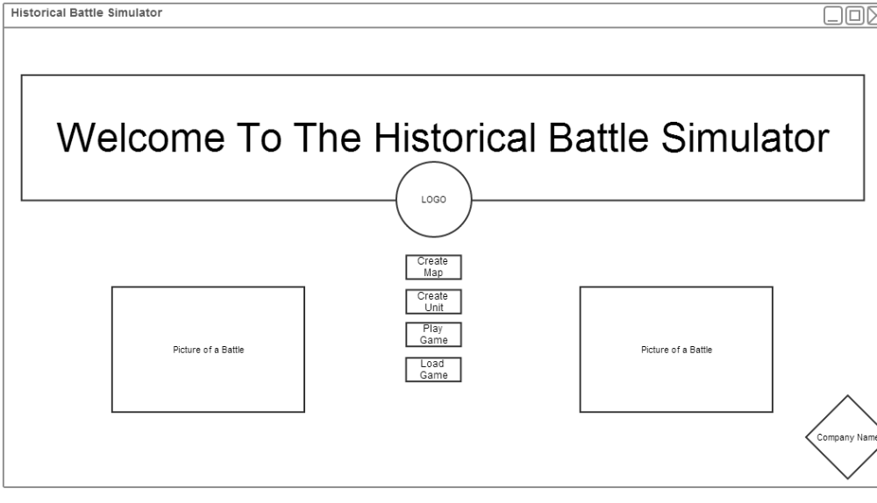
GameBoard in Combat Phase
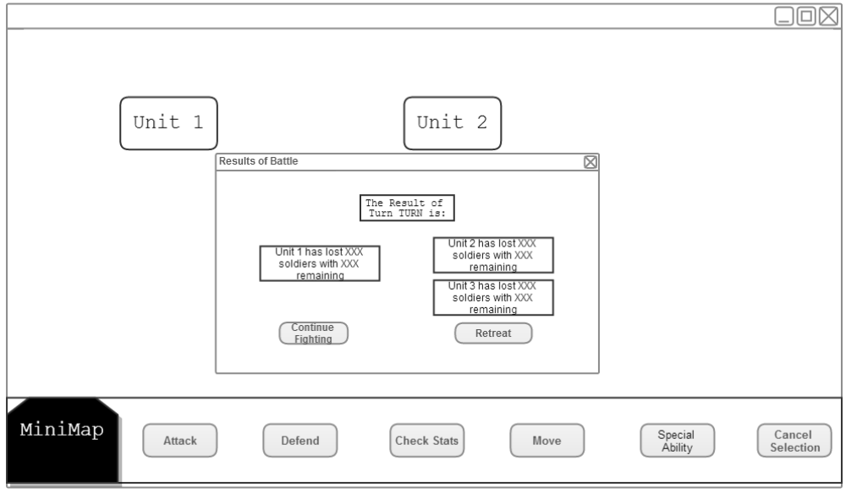
GameBoard with Unit Clicked
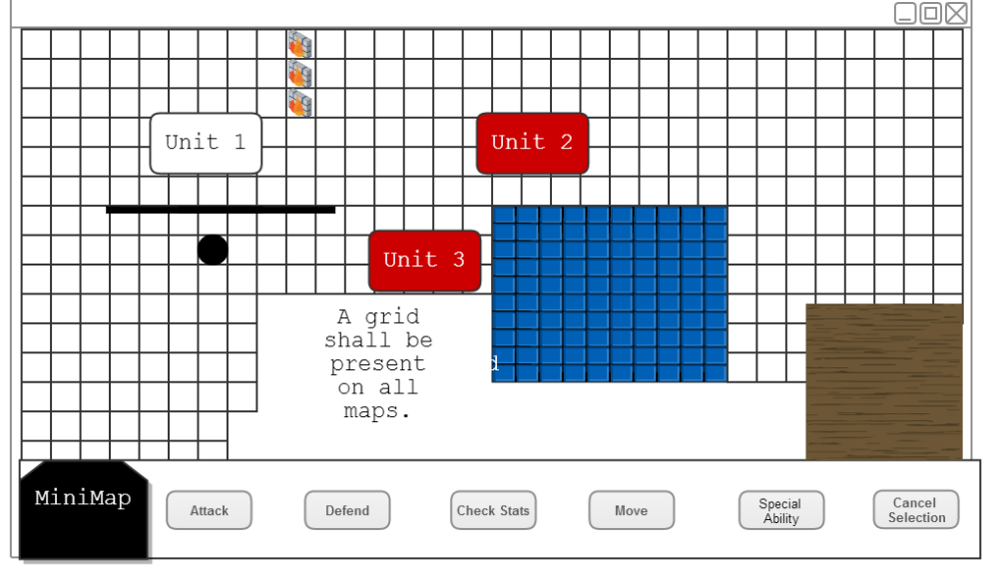
GameBoard with Unit Clicked and Check Stats Enabled
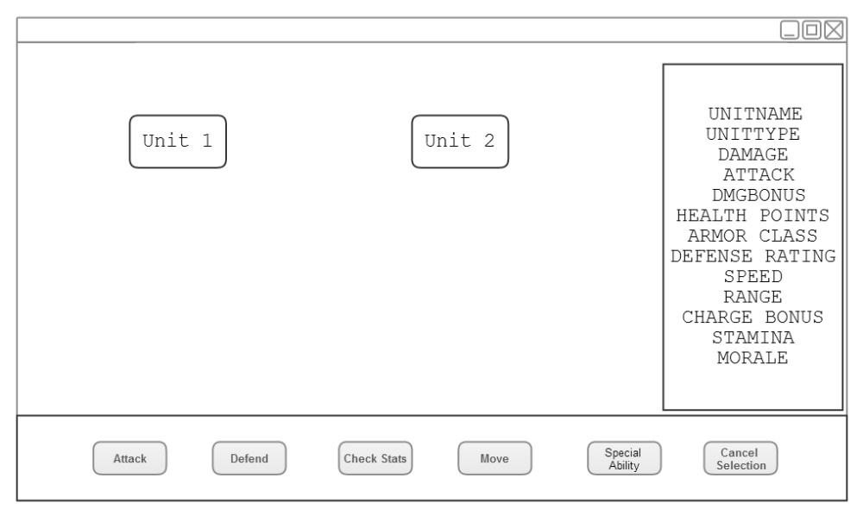
Prompts for User input in Map and Unit Creation
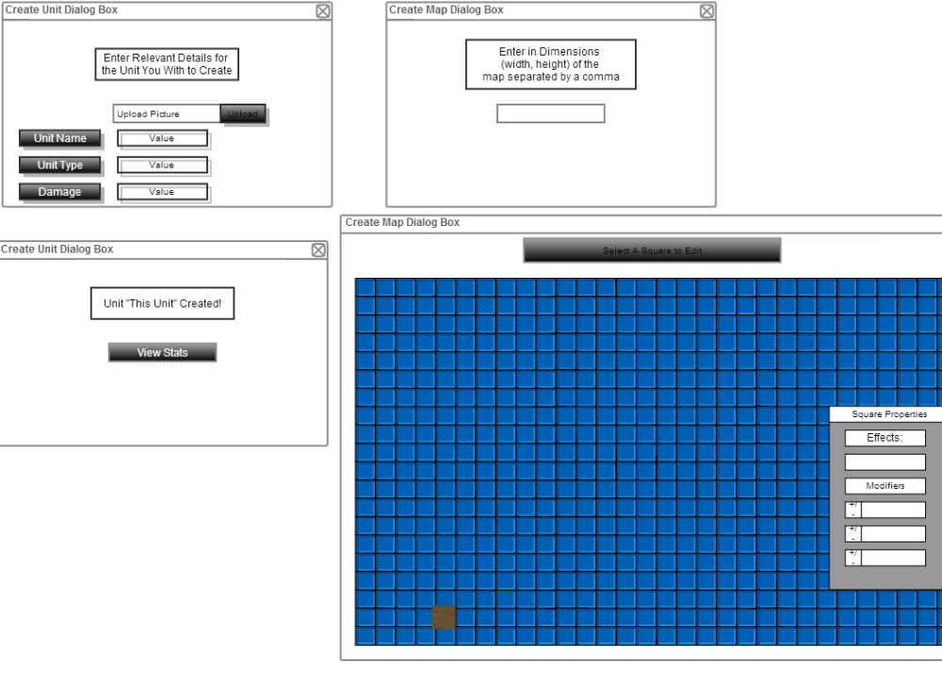
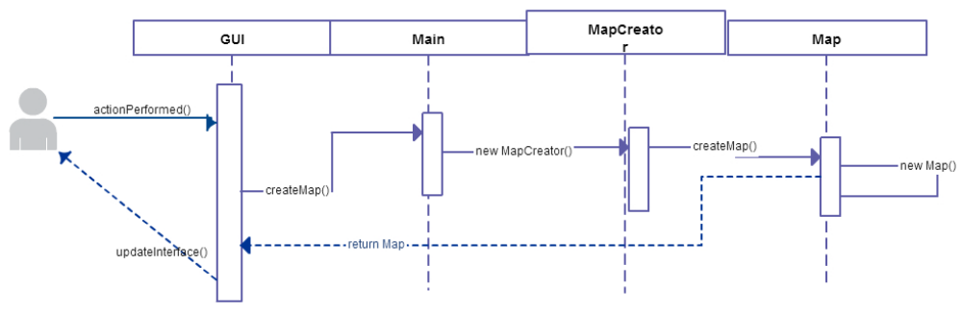

Use Case for Creating a Map

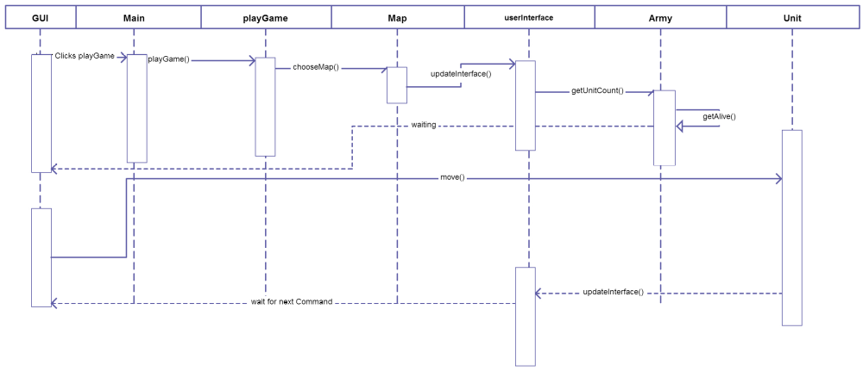
A use Case for Play Game, initialization and a move command

